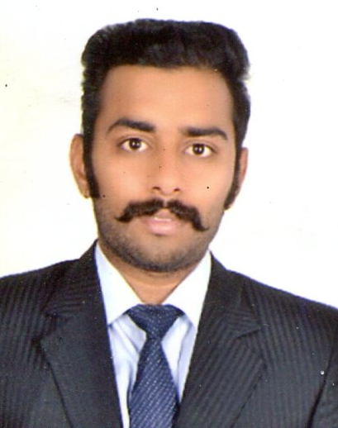
CURRICULUM VITAE

Pawan Singh

M.H.R.M.. (MASTER OF HUMAN RESOURCES MANAGEMENT)

Email: prithivirajsingh05@gmail.com , pawansinghudr05@gmail.com

Mobile. +918769494968

OBJECTIVE

To scale new heights of success with hard work and dedication and leave a mark of excellence on every step and to work for assignments which involve analytical capabilities and professional growth.
CORE STRENGTH

- Fast Learner: Ability to learn and grasp New Techniques & Methods.
- Computer Skills: Sound knowledge in computer.
- Key skills: The ability to adopt the new environment, situations.
- To Manage the Stress: Can work under pressure and can easily adapt as situation demands.

PROFESSIONAL QUALIFICATION

- Master in Human Resource Management (MHRM):
M.H.R.M. in specialization of Human Resource from M.L.S.U., Udaipur approved by AICTE.

TRAINING/INTERNSHIP

- Project : Core HR
- Organisation : Historic Resorts and Hotel , UDAIPUR( HRH Group of Hotels )
- Duration : 2 month
- Working : I have worked in H.R. Dept. under the Gudience of H.R. Manager Mr. Ajay Nagar sir and Executive Mr Thomas sir. I got knowledge related to Labour Laws like PF ACT, ESI ACT, Payment of Gratuity, Payment of Bonus Act, Compensation Act etc.

- HRH is providing super class human resources service and provide complete of human resources knowledge and solutions.

- Involved in day to day human resources activity and performance appraisal, employee engagement sending mails and done clerical work.
- Acting as a back up supervisor and handling clerical work.

CURRENT EMPLOYMENT

- Company Name : Udai Kothi Hotels And Resorts, Udaipur
- Designation : HR Executive
- Key Responsibilities :

1)Maintaining all require daily, weekly & monthly MIS.
2)Maintain Employee records & personal files.
3)Compile and prepare reports and documents pertaining to personal activities.
4)Solving queries related to PF, ESIC, Leave, Salaries, expenses of employees.
5)Any other activity as may be assigned from time to time, for the smooth functioning of the H.R. & Admin. Dept.

ACADEMIC QUALIFICATION

Exam | Board/University | Percentage | Year
MHRM | MLSU | 64.35% | 2015
B.Com | MLSU | 59.0% | 2013
12th Std. | CBSE | 69.2% | 2010
10th Std. | CBSE | 48.0% | 2008

ACHIEVEMENTS

- Participated in college cricket and volleyball team as captain.
- Participated in college level Basket Ball Tournament.
- Participated in State level Basket Ball Tournament
- Participated in college level cultural and educational activities.

IT PROFICIENCY

- Operating System: Windows XP * Application Software: MS Office * Basics of Computer, Internet .

- Date of Birth : 13 November 1990
PERSONAL DETAILS

- Fathers Name : Mr. Ram Singh
- Gender : Male

- Nationality : Indian

- Marital Status : Single

- Language Known : English , Hindi

- Permanent Address : Opp. SBBJ Bank ,Badgaon ,Udaipur (Raj.)

- Correspondence add. : sky line, vidhya vihar, Mumbai

DECLARATION

All the details stated above are true to the best of my knowledge. I hereby declare that the above-mentioned information is correct up to my knowledge and I bear the responsibility for the correctness of the above-mentioned particulars.
Date:
Place: (Pawan Singh)

